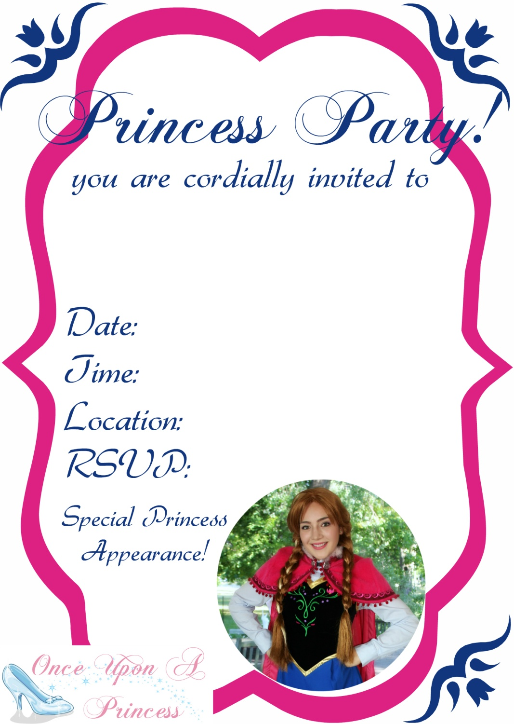

Dd/mm/yyyy

12:00pm-1:00pm

The Queen 613-555-5555

123 Castle St. Princessville

Princess Name’s

#th Birthday